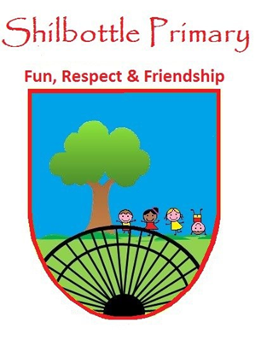
Year 3 Spelling List – Spring 1

Spelling lists for this term are given below. Each week children will have 6 spellings following a spelling rule and 4 spellings from the expected to know lower KS2 words. Children will be tested on these spellings on a Friday in class.
Spelling Homework: To be completed in Homework book. Children are to write out the words in a list and then write a sentence using each word (10 sentences in total).

Week 1  Test date 7/1/22 | Week 2  Test date 14/1/22 | Week 3  Test date 21/1/22 | Week 4  Test date 28/1/22
Spelling rule  Adding the suffix -ion  subtraction  action  injection  celebration  operation  concentration  Lower KS2 spellings  heard  heart  height  history | Spelling rule  Adding the suffix -ian  musician  electrician  magician  optician  politician  mathematician  Lower KS2 spellings  imagine  important  increase  interest | Spelling rule  Adding the prefix re-  recycle  replay  rearrange  renew  refresh  reappear  Lower KS2 spellings  island  knowledge  learn  length | Spelling rule  Homophones  scene seen  week weak  hear here  male mail  be bee  whether weather  Lower KS2 spellings  library  material  medicine  mention
Week 5  Test date 4/2/22 | Week 6  Test Date 11/2/22 | Week 7  Test Date 18/2/22  Spelling rule  Words from the year  creature  disappear  impossible  carefully  length  continuous  Lower KS2 spellings  actual  caught  breathe  circle
Spelling rule  Adding the prefix anti-  antisocial  antifreeze  antiseptic  anti-climax  antibiotic  anticlockwise  Lower KS2 spellings  minute  natural  naughty  notice | Spelling rule  Words from the term  musician  rearrange  weather whether  anticlockwise  celebration  Lower KS2 spellings  minute  height  library  important

